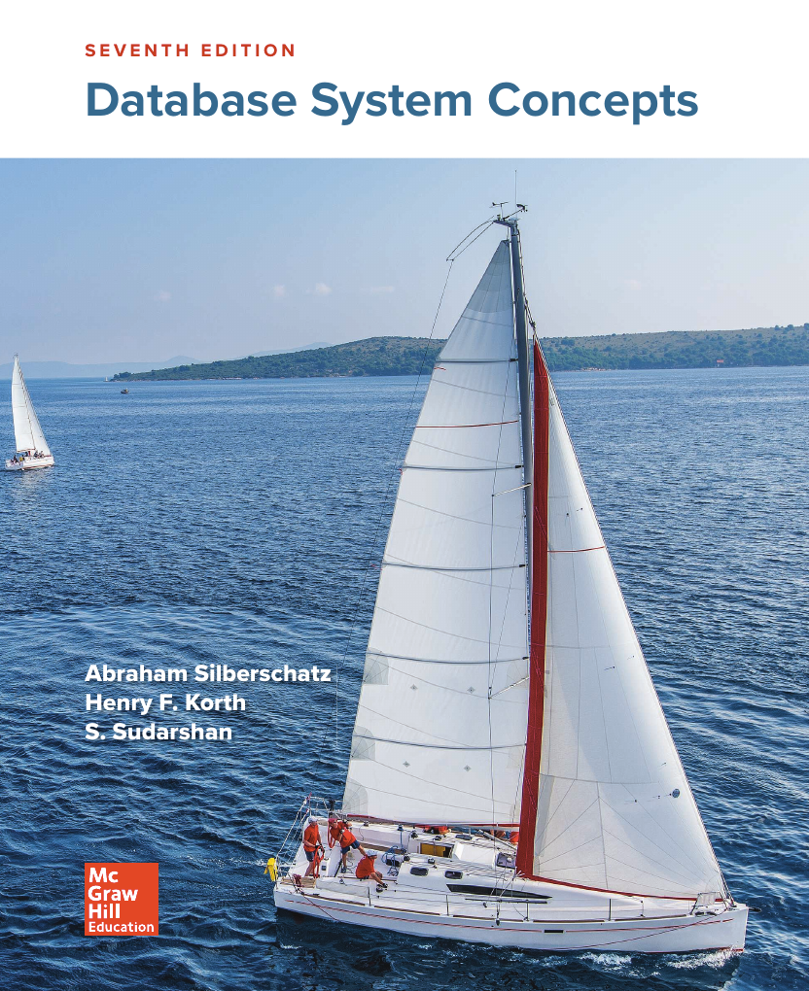
Database System
Concepts ﬁ
Chapter 2



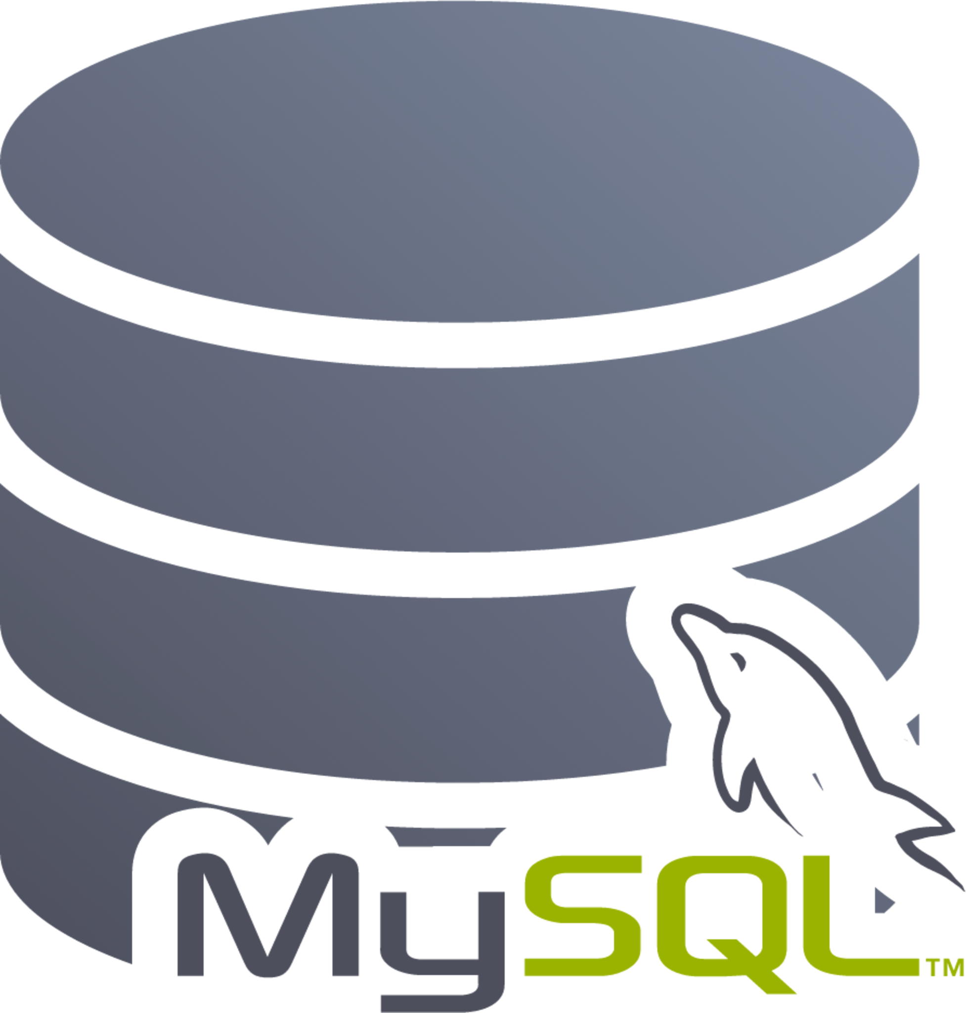

REVISION 1

-------------------------------------------------
Terms (GNU AGPLv3)
This is just a sample!
I have tried to put things like summary, and obviously this is not the solution that I will submit or recommended! I am no way responsible for any illegal use of this file.

If you need direct solutions, please ask ChatGPT, Google Gemini, Anthropic Claude, Hugging Chat, Le Chat Mistral or any other predictive model.

Chapter 2 | Exercises

This chapter has described several major advantages of a database system. What are two disadvantages?
Some disadvantages,
- Increased complexity
- Poor performance
- Requires more knowledge, money to setup, use and maintain
- Larger volume size
- Frequent update
More :: https://www.javatpoint.com/disadvantages-of-dbms

List five ways in which the type declaration system of a language such as “Java” or “C++” diﬀers from the data definition language used in a database.
DDL | Programming language
Creates new object | Doesn’t create new object, rather it creates an abstraction
It can contain consistency constrains to check a value before assigning | No constrain is used, so any values within the same type can be applied
Authorization → everyone can’t access everything | No authorization exists
Only basic data types | Can contain advanced data types like array
Can contain relation between data | Doesn’t contain relation between

List six major steps that you would take in setting up a database for a particular enterprise.
- System requirement specification
- Data model (data type)
- Define integrity constrains
- Define physical layer
- Write application programs (user interface)
- Create/ initialize the database

Suppose you want to build a video site similar to YouTube. Consider each of the points listed in Section 1.2 as disadvantages of keeping data in a file-processing system. Discuss the relevance of each of these points to the storage of actual video data, and to metadata about the video, such as title, the user who uploaded it, tags, and which users viewed it.
বোর্ড বই এর ১.২ সেকশনে কিচু file processing system এর খারাপ দিক দেয়া আছে। এখন যদি ডেটাবেজে কয়েকটি ভিডিও এবং ভিডিও এর metadata (properties নামে আমরা অনেকে চিনি) আপনাকে জমা রাখতে বলে ওই ডেটাবেজ এর ভেতরে, তাহলে ওই খারাপ দিকগুলো কি আসলেই প্রভাব বিস্তার করতে পারবে কিনা সেটা জানতে চাওয়া হচ্ছে। যেহেতু এটা ভিডিও (like YouTube) তাই বার বার update করার ঝামেলা নেই, ব্যপারটা এমন।
Disadvantage | Video | metadata
Data redundancy and inconsistency | No effect | It can be issue, if multiple metadata is stored per one video
Difficulty in accessing data | Less relevant | It can be issue, if search filter is used
Data isolation | Not much affect | Can be in seperate files leading to isolation
Integrity problems | Not much problem | Constrains can be difficult to implement like unique ID
Atomicity problems | If a video is uploaded and it’s metadata isn’t added then it may cause atomicity | <-
Concurrent-access anomalies | Won’t affect because video is not updated often | Won’t affect because video is not updated often
Security problems | May cause problem if sustem has authorization | <-

Keyword queries used in web search are quite diﬀerent from database queries. List key diﬀerences between the two, in terms of the way the queries are specified and in terms of what is the result of a query.
Keyword query | Database query
No specific syntax | Has a specific syntax
Result is an unordered list of URL | Result is a table

List four applications you have used that most likely employed a database system to store persistent data.
Some apps that I used might have used databases are below,
- YouTube: Youtube stores metadata about videos in it’s database which is persistent and doesn’t change frequently.
- Dictionary: Dictionary apps uses database for storing words which are preety much persistant and doesn’t get updated frequently.
- Gboard: Gboard, a keyboard type application stores keyboard layouts, and other attributes like preferences are saved in persistant database.
- Daraz: Daraz stores product information in persistant database. Because product information is not pretty much updated or rarely updated.

যেসব ডেটা পরিবর্তন হয় না সেগুলো আমি চিন্তা করেছি আর কিছূ না

List four significant diﬀerances between a file-processing system and a DBMS.
File processing | DBMS
No centralized control of data | Data is controlled in one or multiple instance by one system
Data redundancy can be occurred by different files | Data redundancy is used to link multiple occurrence of same database
Change in one table doesn’t change other same fields | Change in one occurrence applies in all other occurrences
Doesn’t provide security, because authentication can’t be applied | Provide authentication, so everyone can’t access everything

Explain the concept of physical data independence and its importance in database systems.
Physical data independence is the case when it is separated from the logical view to ensure logical view is not affected whenever a change is made to physical data.

List five responsibilities of a database-management system. For each responsibility, explain the problems that would arise if the responsibility were not discharged.
Some responsibility contains,
- Redundancy minimize – without it, our database will use much more storage volume
- Integrity maintain – without integrity, when one occurance of data will be updated, it won’t update other occuraces automatically
- Concurrency support – without concurrency if multiple users try to do same operation, system may not work in the expected way
- Authentication – without it anyone can access or edit data which is out of the scope of his
- Backup and restore – without it, we may lose data permanently

Check web or book for more responsibilities!

List at least two reasons why database systems support data manipulation using a declarative query language such as SQL, instead of just providing a library of C or C++ functions to carry out data manipulation.
Firstly to make DBMS more easy and simple, SQL is used. C or C++ is much harder to write manually, and different people can use different types of code for doing the same thing, but their complexity will differ which will make it difficult to work on the same codebase.
Secondly, SQL can provide a standardization, where all of its code is highly optimized. Otherwise, programming languages could be implemented in different ways which will lack a default standard and optimization.

Assume that two students are trying to register for a course in which there is only one open seat. What component of a database system prevents both students from being given that last seat?
Transaction management is responsible for handling this case. This part of the database deals with consistency.
(Read main book for learning more)

Explain the diﬀerence between two-tier and three-tier application architectures. Which is better suited for web applications? Why?
Currently, three-tier is better suited for web applications.
In two tier applications, user can directly interact with the database through front end which can cause many issues like performance. Every calculation is done in the frontend part. And the users can also database through frontend which can also cause security concerns.
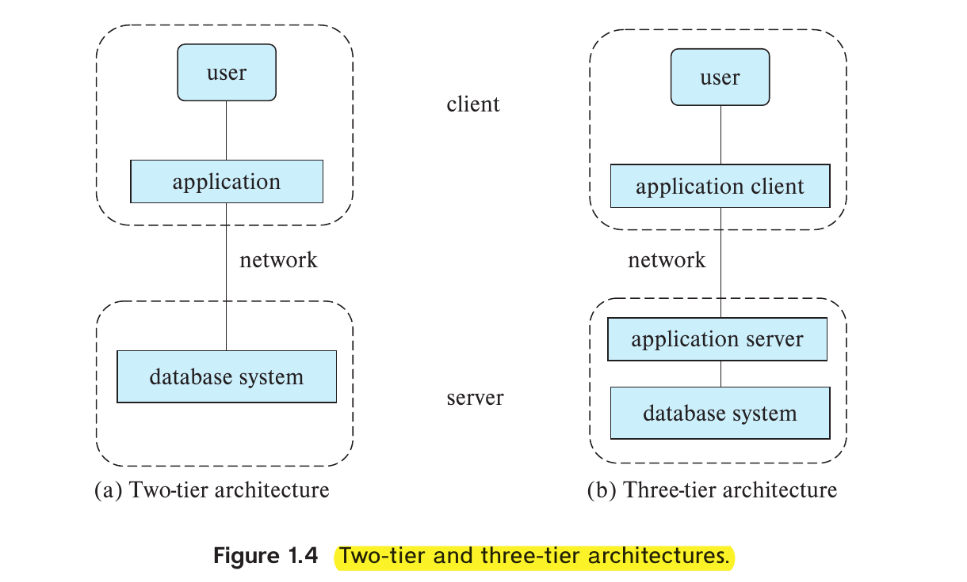
On the other hand, in the three tier application, we have a backend server in between the database and the frontend. The frontend or application server directly communicates with the database, and provide services for the frontend which can gives its users more performance alongside security and authentication support.

List two features developed in the 2000s and that help database systems handle data-analytics workloads.
Firstly, graph databases were introduced, mainly used for social networks. Because social networks can’t be described in tables efficiently. It made the social networking more practical.
Secondly, NoSQL were also created to facillate lightweight form of data management. It was also needed for data-intensive applications. At that time data mining became ubiquitous and new frameworks were beign developed.

Explain why NoSQL systems emerged in the 2000s, and briefy contrast their features with traditional database systems.
NoSQL systems were mainly emerged to solve some leggings of RDBMS systems. Some of the problems contain solving big data, scalability, real-time processing issues. Some of the features are,
- Scalability: Traditional databases couldn’t scale horizontally because it has a fixed data type. On the other hand in NoSQL data type is quite flexible.
- Performance: Modern applications may need intensive use of data. For example data mining applications.
- Big data: Social networks doesn’t have a fixed pattern so it’s hard to implement in the relation table structure.

Describe at least three tables that might be used to store information in a socialnetworking system such as Facebook.
For facebook, we may use three tables, ‘user’ table, ‘friend’ table and ‘posts’ table. Here’s a short description,
- User table:
In user table we can put,
  - unique id
  - user name
  - email
  - password (encrypted)
  - data of birth
  - profile picture
  - gender
- Friend table:
In friend table, we can link to another user table,
  - unique id
  - first friend’s unique id
  - second friend’s unique id
  - status
- posts table:
this table may contain posts of a user,
  - unique id
  - user id of the post creator
  - content
  - date

---
“In order to escape a road of solitude, one has to work hard, and forge a new path with their own power.” – Gaara

